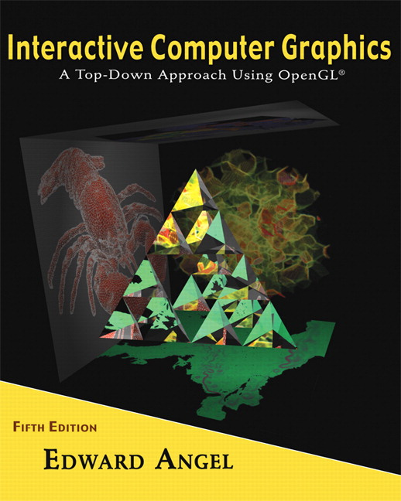 COSC 4370
Name: ____________________ TERMINAL NUMBER ____
Programming Assignment 2 Acceptance Testing:

After you downloaded your zipped project from BB and rebuilt it using the 200 PGH Visual Studio 2010, take screenshots of the output produced, and insert it in this file ……..
1. Keyboard f so you can get the Front image of BUS.
SCREENSHOT Output of your program is:
……..
Copy and Paste your gluLookAt here
……..
2. Keyboard b so you can get the Back image of BUS.
SCREENSHOT Output of your program is:
……..
Copy and Paste your gluLookAt here
……..
3. Keyboard r so you can get the right Side image of BUS.
SCREENSHOT Output of your program is:
……..
Copy and Paste your gluLookAt here
……..
4. Keyboard t so you can get the Top image of BUS.
SCREENSHOT Output of your program is:
……..
Copy and Paste your gluLookAt here
……..
5. Keyboard i so you can get the Isometric image of BUS.
SCREENSHOT Output of your program is:
……..
Copy and Paste your gluLookAt here
……..
6. Fly Through the BUS through the door so you are in the middle of the BUS, looking towards the front of the BUS.
SCREENSHOT Output of your program is:
……..
7. Copy and Paste your .c (.cpp) file here:
…….

When done attach this file to “Testing Programming Assignment 2” BB assignment.

